The following describes how to update Eclipse with the EGit plugin, clone a GitHub repository and make the repository available in Eclipse as a Force.com project.  Once complete, you will be able to access code that is now maintained in GitHub instead of Beanstalk.

These instructions were tested on a Windows 10 PC with Eclipse Oxygen v4.7.3a and Force.com IDE v38.

1. Upgrade Eclipse with latest EGit:  
   <https://www.eclipse.org/egit/download/>  
     
   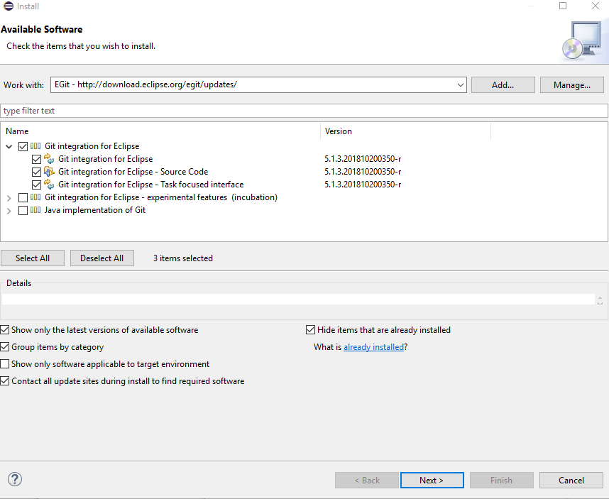  
     
     
   I encountered version conflict errors and resolved using ‘Update items already installed’ option  
     
   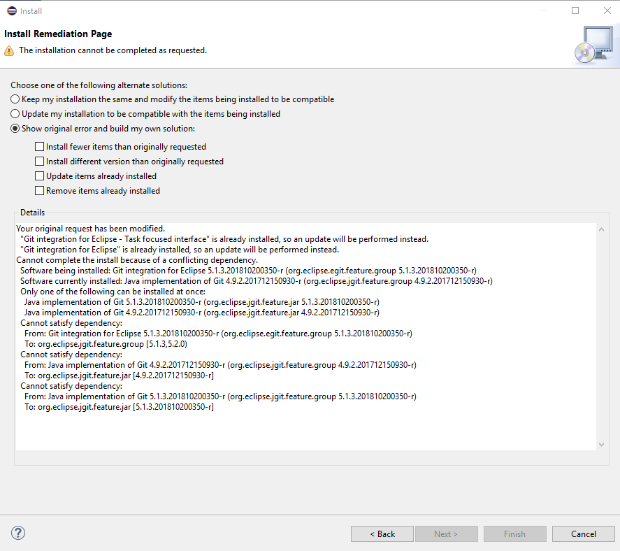  
     
   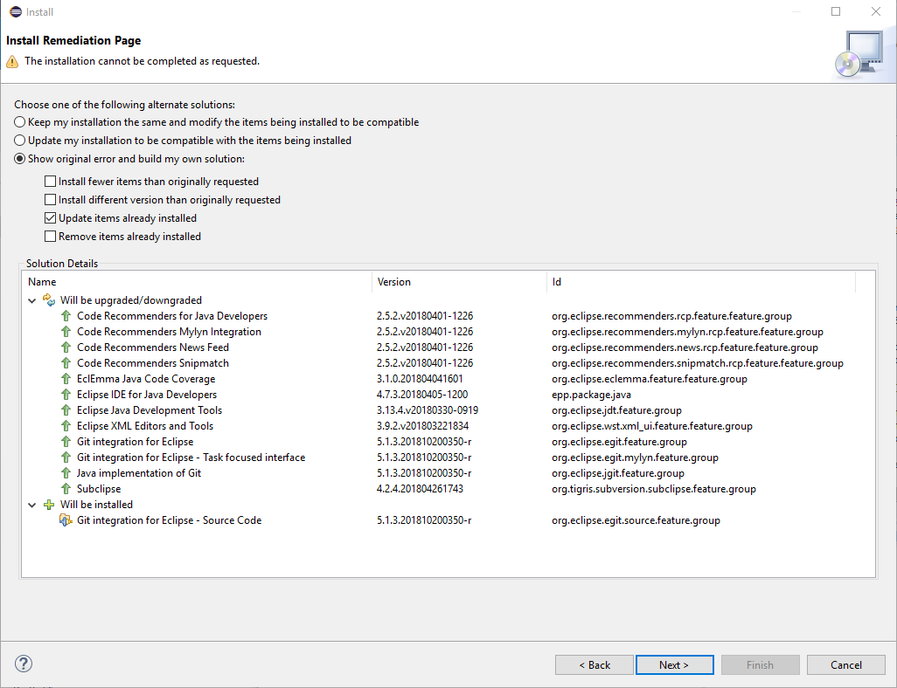  
     
     
   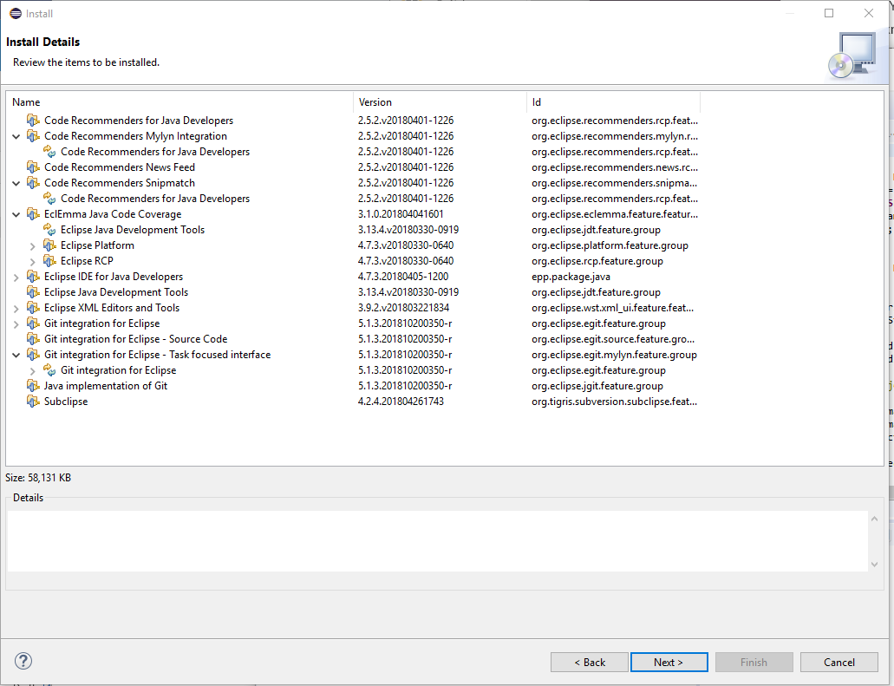
2. Create a personal access token for accessing GitHub via Eclipse (if you do not already have one).  This is needed in order to clone a GitHub repo:  
   <https://help.github.com/articles/accessing-github-using-two-factor-authentication/#authenticating-on-the-command-line-using-https>  
   <https://help.github.com/articles/creating-a-personal-access-token-for-the-command-line/>  
     
   Note: ‘Send verification email’ link did not appear  
   Use the token in place of a password
3. Create a GitHub account if you do not already have one.  Configure with two-factor authentication.  Provide me or John Daniel with your GitHub username so he can configure access.  Proceed after John confirms your account is complete.    
   <https://github.com/>
4. Sign in to your GitHub account:  
   <https://github.com/login>  
     
   Switch dashboard context to rootstockmfg to see list of available repositories:  
   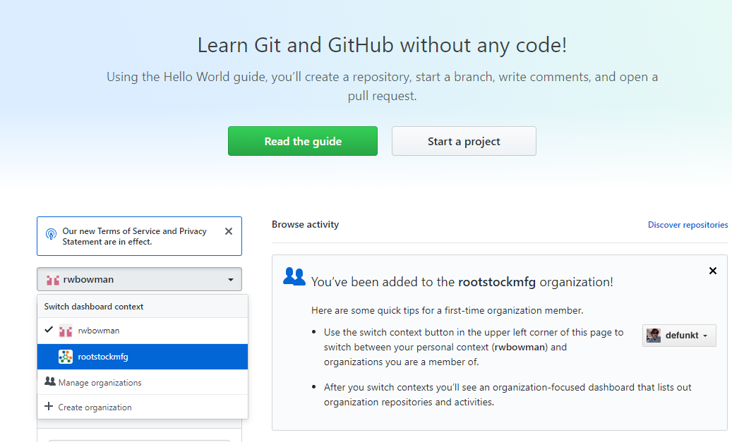
5. Clone a GitHub repository and make it accessible in Eclipse via the Force.com perspective.   
     
   The process is similar to checking out a project from SVN.   
     
   Select the sfdev repository  
   Select the ‘Clone or download’ option.  You can choose to use the HTTPS or SSH option.  This example uses HTTPS.  
   Copy the URL  
   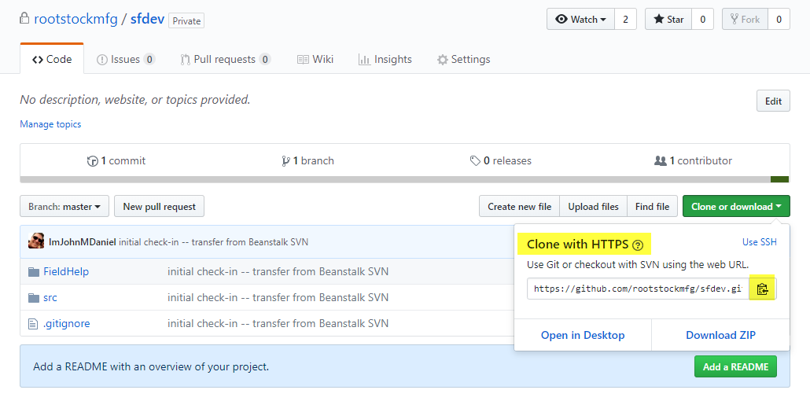  
   Select the Force.com perspective within Eclipse  
   Select File > Import… > Git > Projects from Git  
   Next  
   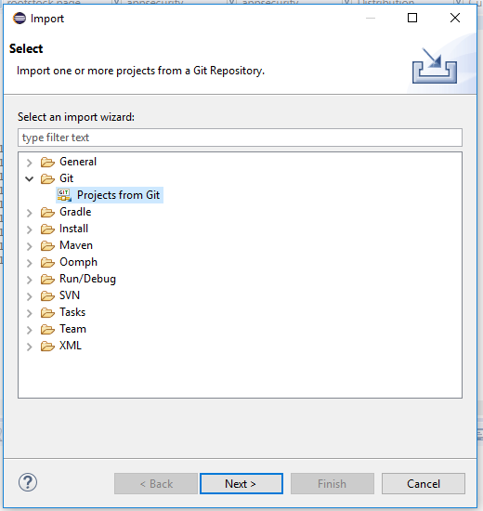  
     
   Select Clone URI  
   Next  
   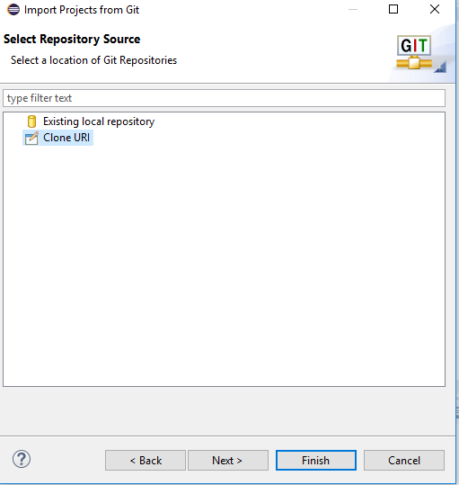

Set URI to the Git repository URL  
Leave User and Password blank  
Next  
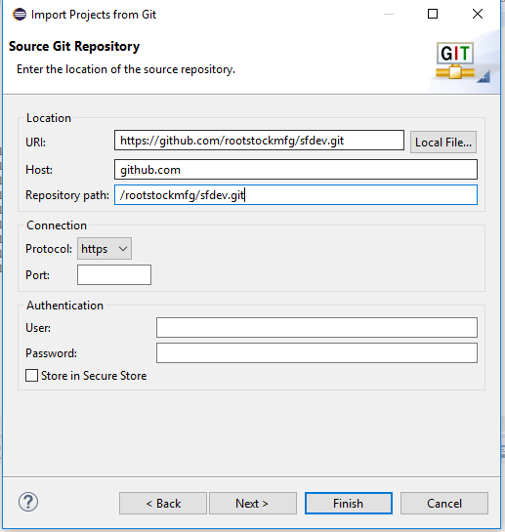  
  
Select Master as the branch  
Next  
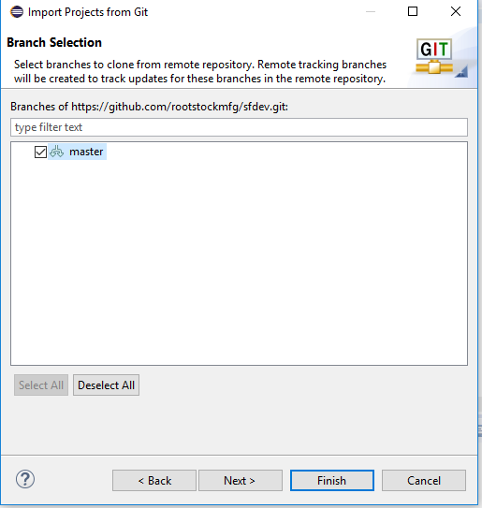  
  
Browse to the root directory where your existing SVN projects are stored.  The directory will be appended with the Git repository name.  I appended ‘-git’ as a personal preference.  
Next  
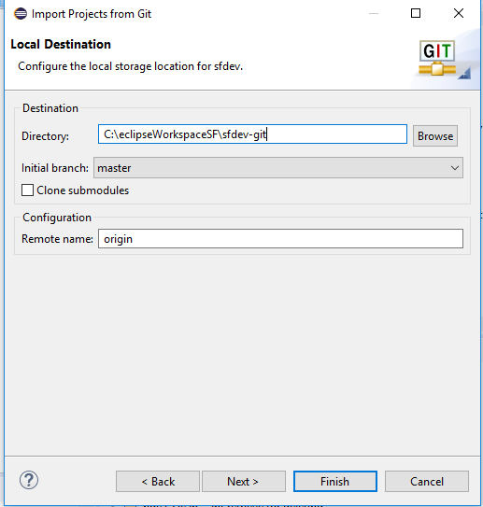  
  
  
Enter login credentials using your token as the password.  The GitHub repository files are imported and now exist as a Git repository within Eclipse but the Eclipse project does not yet exist.  
  
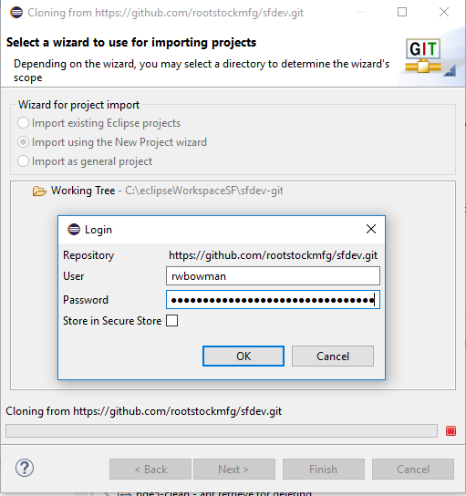  
  
Now create a new project and Force.com Nature  
Select Import using the new Project wizard  
Finish  
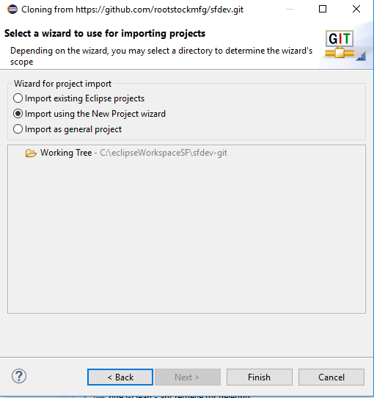  
  
Select Force.com Project as the new project type  
Next  
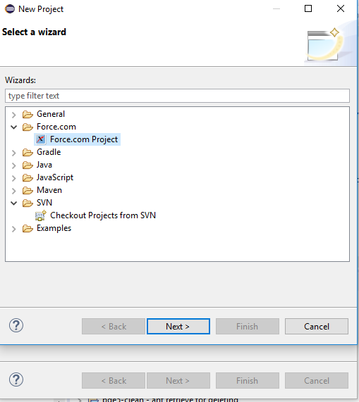  
  
Enter the project name to match the Git repository name, in this case, sfdev-git.  This ensures the correct directory is used.  
Enter your SF login credentials for the appropriate org, in this case, pde3.  
Next  
  
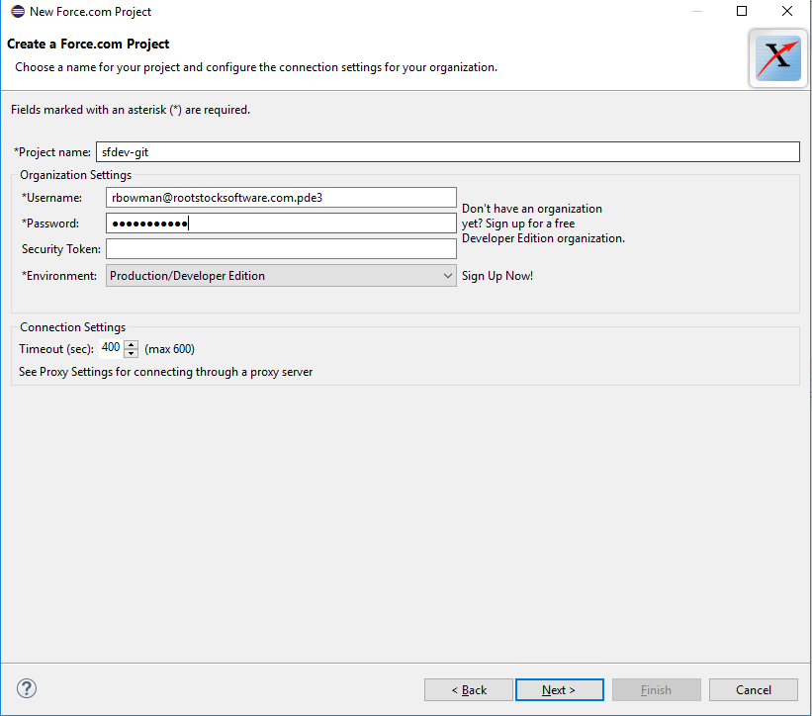  
  
Choose None

Finish

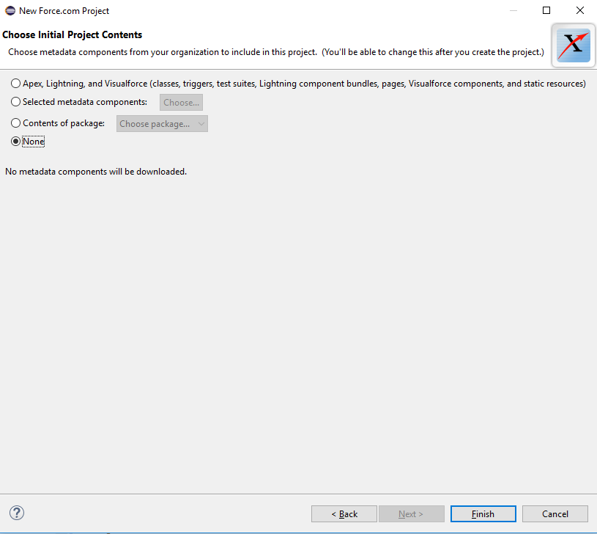

The sfdev-git project now appears in the Force.com perspective but the package.xml is blank.  
To correct this, expand the project and R-click on package.xml  
Select Replace With > HEAD Revision  
Select Discard Changes  
  
